Advanced JUnit Testing Exercises

Exercise 1: Parameterized Tests

EvenChecker.java

package com.hemavathy.evenchecker;

public class EvenChecker {

public boolean isEven(int number) {

return number % 2 == 0;

}

}

EvenCheckerTest.java

package com.hemavathy.evenchecker;

import static org.junit.jupiter.api.Assertions.assertEquals; import org.junit.jupiter.params.ParameterizedTest; import org.junit.jupiter.params.provider.ValueSource; public class EvenCheckerTest {

private flnal EvenChecker evenChecker = new EvenChecker(); @ParameterizedTest

@ValueSource(ints = {2, 4, 6, 8, 10})

void testIsEvenWithEvenNumbers(int number) { assertEquals(true, evenChecker.isEven(number));

}

@ParameterizedTest @ValueSource(ints = {1, 3, 5, 7, 9})

void testIsEvenWithOddNumbers(int number) { assertEquals(false, evenChecker.isEven(number));

}

}

# output

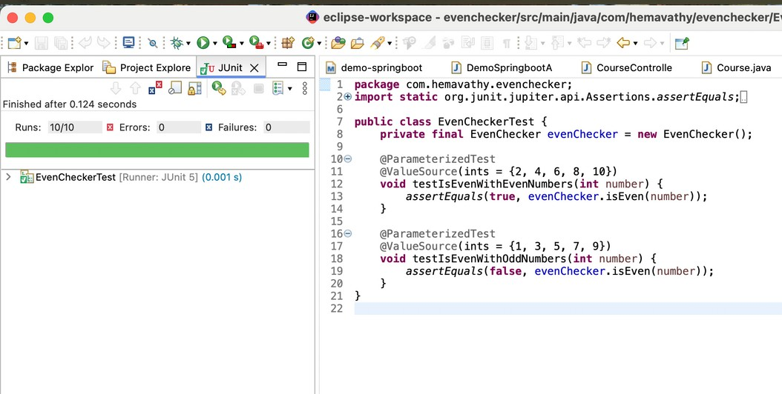

Exercise 2: Test Suites and Categories EvenChecker.java

package com.hemavathy.evenchecker; public class EvenChecker {

public boolean isEven(int number) { return number % 2 == 0;

}

}

### OddChecker.java

package com.hemavathy.evenchecker; public class OddChecker {

public boolean isOdd(int number) { return number % 2 != 0;

}

}

EvenCheckerTest.java

package com.hemavathy.evenchecker;

import static org.junit.jupiter.api.Assertions.assertTrue; import org.junit.jupiter.params.ParameterizedTest; import org.junit.jupiter.params.provider.ValueSource;

public class EvenCheckerTest {

EvenChecker checker = new EvenChecker();

@ParameterizedTest @ValueSource(ints = {2, 4, 6}) void testIsEven(int num) {

assertTrue(checker.isEven(num));

}

}

## OddCheckerTest.java

package com.hemavathy.evenchecker;

import static org.junit.jupiter.api.Assertions.assertTrue; import org.junit.jupiter.params.ParameterizedTest; import org.junit.jupiter.params.provider.ValueSource;

public class OddCheckerTest {

OddChecker checker = new OddChecker();

@ParameterizedTest @ValueSource(ints = {1, 3, 5}) void testIsOdd(int num) {

assertTrue(checker.isOdd(num));

}

}

AllTests.java

package com.hemavathy.evenchecker;

import org.junit.platform.suite.api.SelectClasses; import org.junit.platform.suite.api.Suite;

@Suite

@SelectClasses({EvenCheckerTest.class, OddCheckerTest.class}) public class AllTests {

// No code needed here; annotations do everything

}

# output

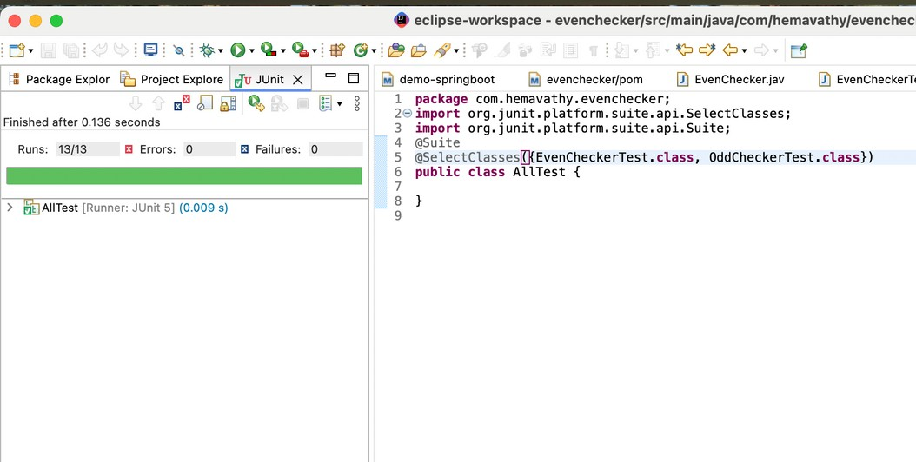

Exercise 3: Test Execution Order

OrderedTests.java

package com.hemavathy.evenchecker; import org.junit.jupiter.api.Order; import org.junit.jupiter.api.Test;

import org.junit.jupiter.api.TestMethodOrder;

import org.junit.jupiter.api.MethodOrderer.OrderAnnotation; @TestMethodOrder(OrderAnnotation.class)

public class OrderedTests { @Test

@Order(3) void testC() {

System.out.println("Test C executed");

}

@Test @Order(1) void testA() {

System.out.println("Test A executed");

}

@Test @Order(2) void testB() {

System.out.println("Test B executed");

}

}

# output

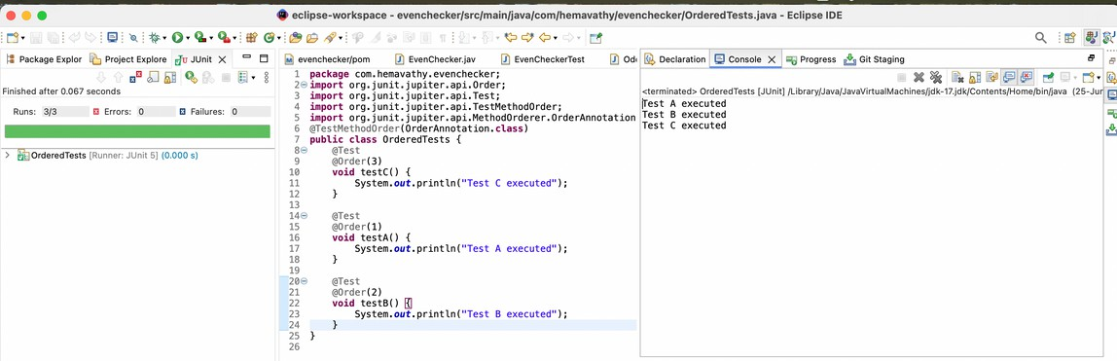

Exercise 4: Exception Testing

ExceptionThrower.java

package com.hemavathy.evenchecker; public class ExceptionThrower {

public void throwException(String input) { if (input == null) {

throw new IllegalArgumentException("Input cannot be null");

}

System.out.println("Valid input: " + input);

}

}

### ExceptionThrowerTest.java

package com.hemavathy.evenchecker;

import static org.junit.jupiter.api.Assertions.assertThrows; import org.junit.jupiter.api.Test;

public class ExceptionThrowerTest {

private final ExceptionThrower thrower = new ExceptionThrower(); @Test

void testThrowExceptionWithNull() { assertThrows(IllegalArgumentException.class, () -> {

thrower.throwException(null);

});

}

@Test

void testThrowExceptionWithValidInput() {

// This will not throw an exception thrower.throwException("Hello");

}

}

# output

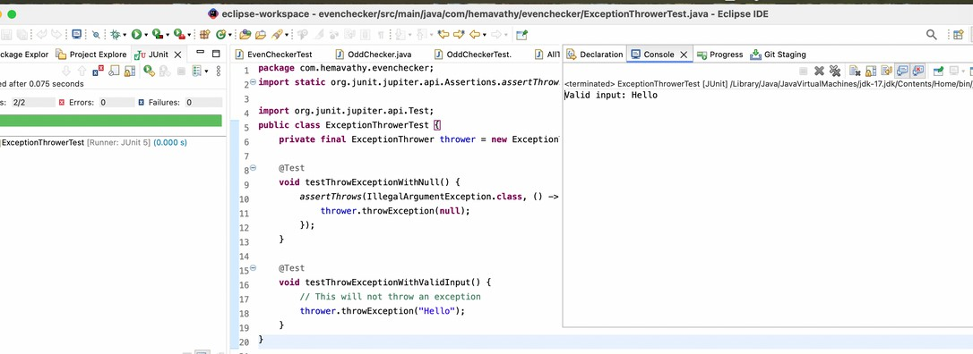

Exercise 5: Timeout and Performance Testing

## PerformanceTester.java

package com.hemavathy.evenchecker; public class PerformanceTester {

public void performTask() { try {

// Simulate a task that takes some time Thread.sleep(200); // 200 milliseconds

} catch (InterruptedException e) { Thread.currentThread().interrupt();

}

}

}

### PerformanceTesterTest.java

package com.hemavathy.evenchecker;

import static org.junit.jupiter.api.Assertions.assertTimeout; import java.time.Duration;

import org.junit.jupiter.api.Test; public class PerformanceTesterTest {

private final PerformanceTester tester = new PerformanceTester(); @Test

void testPerformTaskCompletesWithinTimeLimit() { assertTimeout(Duration.ofMillis(500), () -> {

tester.performTask();

});

}

}

output

